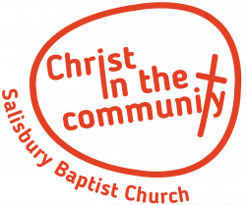
Kings Kids/Youth/Mid-Week socials
Registration form

As well as contact details we would be grateful if you would share any information about your child, which may help us to ensure that he or she is safe and gets the best from their time at Salisbury Baptist Church. All helpers comply with the Church’s ‘Safe to Grow’ policy and have an active DBS with Salisbury Baptist Church.
Please complete and return this form to Hannah Giles or Wendy Orphan who will be happy to give further information or discuss your child’s needs with you.
Child’s name:
Date of Birth:
Address:
Parent/Guardian’s Name:
Home phone:

Mobile Phone:
Email:
Child’s Allergies:
Any Medical condition:
Medication:
Special Needs:
Child’s Interests:
Any other comments:

Parental Consent – delete where appropriate:
I give/do not give permission for my child to be photographed during any activities or trips that they may attend with at Salisbury Baptist Church.
I give/do not give permission for any photos that include my child to be used for Salisbury Baptist Church’s social media.
I give/do not give permission for my child to sample food and drink (we offer squash and a biscuit during the sessions and sometimes do cooking, such as bread, which we taste).
I give/do not give permission for a DBS qualified volunteer to toilet my child.

Parent/Guardian: Date:

